Supported Browsers: Chrome, Edge, and Firefox.
Unsupported Browsers: Safari on a Mac computer or iphone.
Login to the Companies Online system using your existing account or create an account.

Main Menu
Click on Business Names:

Click on Register a Partnership:
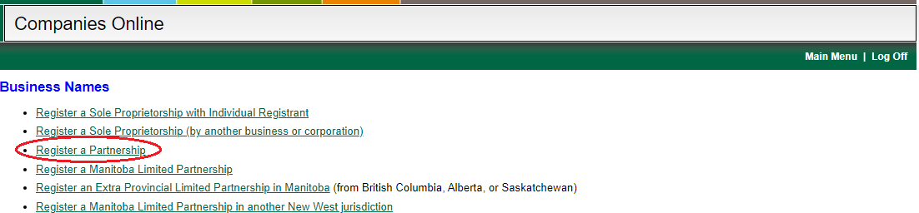

Open Service Request
Click on Continue

Note: You have 5 days to complete the Service Request once it has been started. Any information entered is saved and the Service Request can be re-opened and completed later. If you have incomplete Service Requests a yellow bar will display on the main menu:
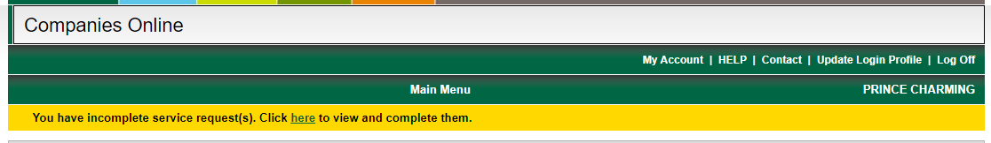
Click on the link in the yellow bar to display your Service Request(s):

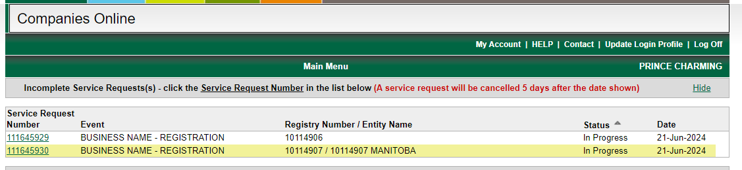
Click on the link for the Service Request that you want to complete.
After 5 days the Services Request is automatically cancelled, and you will need to start a new one.

Name Selection
Choose one of the following options:
- Named Business - I have searched and reserved the name I wish to use.
  - Enter the Reservation Number and click on Lookup. The reserved name will be displayed.
Note: If you receive an error after entering the reservation number, please contact the Companies Office at (204) 945-2500 for assistance.
- Numbered Name - I wish to register a numbered company in Manitoba.
  - A pop-up screen will display requesting confirmation that you wish to proceed with registration of a numbered name:
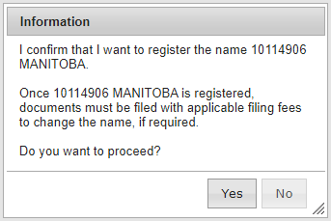
- Click on Next Page

Documents to Attach (Conditional – proceed to next section if this screen doesn’t display)
This screen is displayed if a consent was required on the approved Name Reservation. Attach a pdf version of the signed consent.
- Click on Choose File.
- Locate the document on your computer.
- Once located, select the document, and click on Upload. When uploaded, the document will appear in the box.
- Repeat steps if addition documents are required.
- Click on Next Page
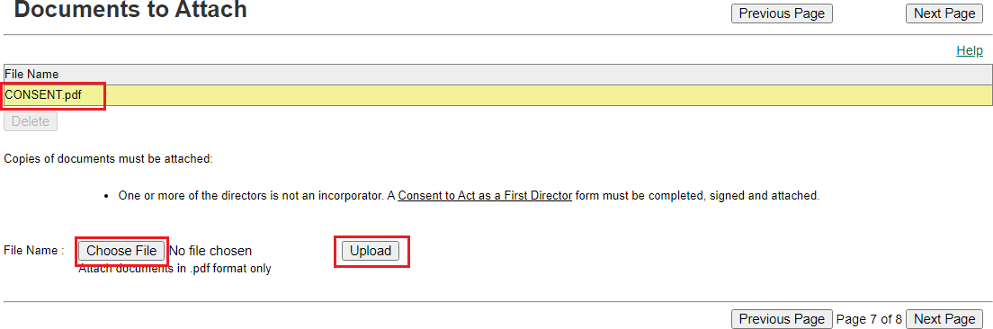

General Information
Date of Start of Business – click on the calendar to select the date. Note the following:
- The date selected cannot be more than 30 days in the future.
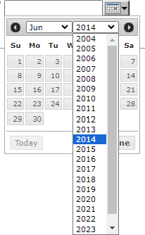
- If the date was in the past, click on the Year drop-down to select the year. If the date was more than 10 years ago, select the oldest year and then click on the Year again to display older years:
- Click on Next Page

Business Location
- More than one business location can be entered.
- Box numbers in Winnipeg and Brandon are not acceptable online. Please complete a paper application.
To add a business location:
  - Enter the business location address (including postal code)
  - Click on Add
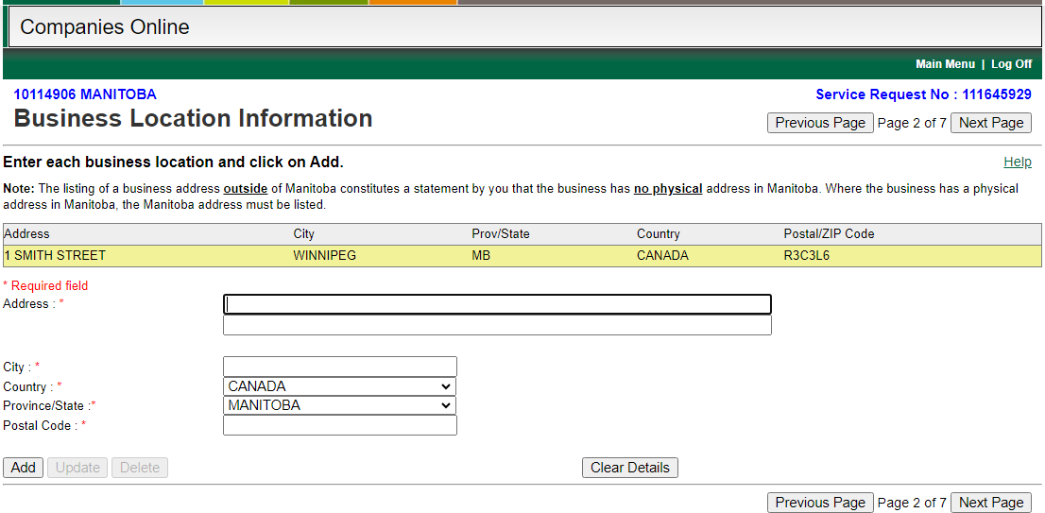
  - Address will appear in the box above:
  - Repeat these steps if there is another business location.
  - Click on Next Page

To correct information entered:
  - Click on the address in the box.
  - Correct the information.
  - Click on Update and ensure the information in the box was updated.
  - Click on Next Page

Mailing Information
Click on the Copy Filer’s Address button, or enter address (this is the address where renewals will be sent)
  - Firm Name (Optional): Can be completed if the address being entered is for a firm (i.e. a law firm or accounting firm). Do not enter the Business Name being registered or an address in this field.
  - Attention (Optional): Can be left blank.
  - Email Address: Select the checkbox and provide an email address if you want to receive an email when the Renewal is due. Otherwise, leave this blank.
  - Click on Next Page
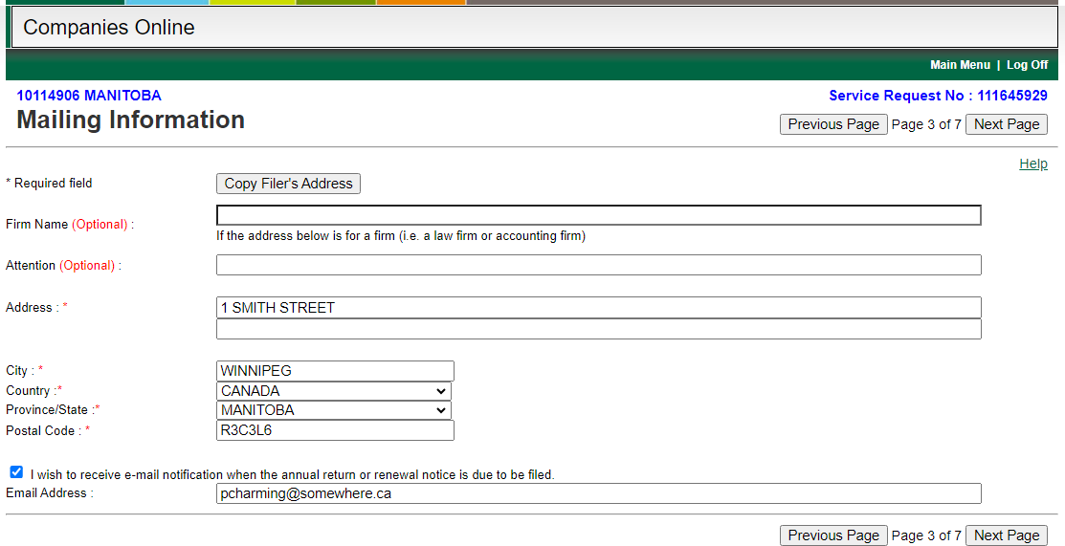

Partner Information
If there are no partners residing in Manitoba the registration cannot be filed online as a Power of Attorney is required. Please submit a paper application.

Partner Type - Individual
    - Enter the partner’s name and address.
    - Click on Add to display their name in the box.
    - Repeat for each partner.
    - Click on Next Page.

Partner Type – Entity on record in Manitoba
Select this option if a partner is another business name or corporation that is already registered or incorporated in Manitoba. You will need the Registry Number to proceed.

Important: You must be authorized to file documents online for the entity that will be entered as a partner. If you receive an error indicating that you are not authorized to update the entity online you may need to:
- Login with a different username (if you previously filed documents online for the entity you may have used a different username), or
- File a paper application.
  - Select Entity on record in Manitoba option.
  - Enter the Registry Number and click on Look Up.
- If you are authorized to file documents online for entity, the name and address will be displayed, and you can continue to the next step.
- If you are not authorized to file documents online for entity, an error will be displayed as noted above.
  - Click on Add to display the name in the box.
  - Repeat for each partner who is not an individual.
  - Click on Next Page.
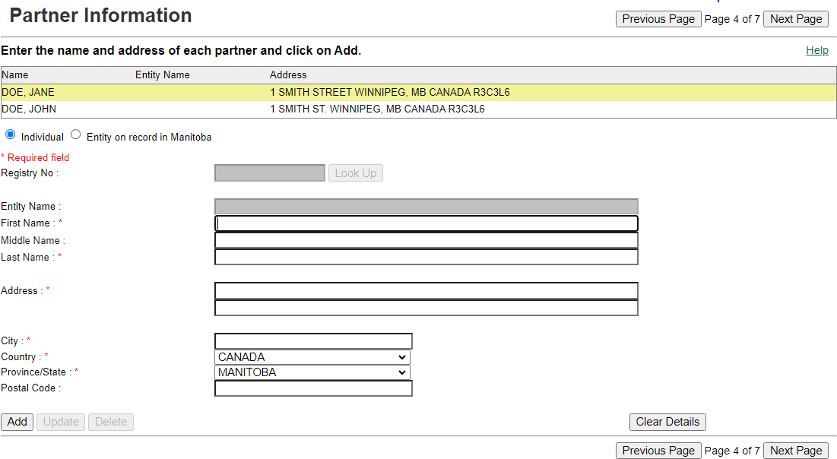

CRA Business Number
The Business Number (BN) is assigned by the Canada Revenue Agency (CRA). The partners may have a BN if they:
    - Previously operated a business as a partnership.
    - Remitted RST, HET, or CCT

    - Collected GST/HST
    - Imported or exported.
    - Had annual sales greater than $30,000.
    - Operated a taxi or limousine service.
Select the appropriate option (insert the BN9 if you have a BN):
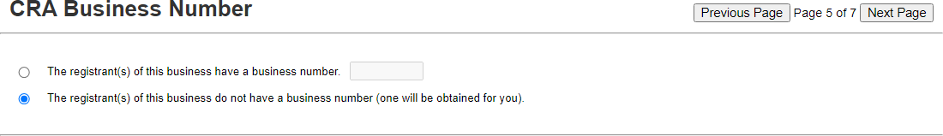

Click on Next Page.

Nature of Business
  - The Nature of Business may be displayed if you filed a Name Reservation and entered the reservation number on the Name Selection page. Make changes if needed.
  - If registering a Numbered Name, “Miscellaneous Services” will be displayed, but must be changed to show the correct Nature of Business.
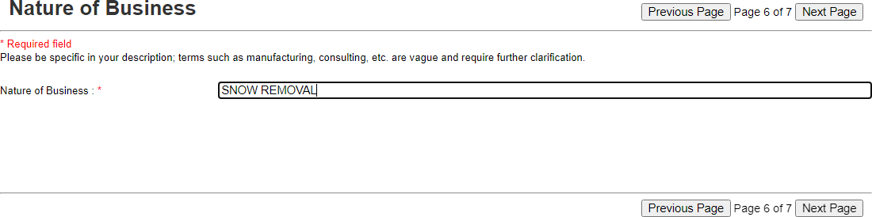

Confirmation
  - Client Reference Number: Leave blank.
  - Effective Date: Documents can be dated up to 30 days in the future. Note:
documents will be processed and released after this date.
  - Expedited Service: Select the checkbox if you require a faster turnaround time. There is an additional fee charged for this service (double the filing fee).
  - Click on the Pre-Registration Report button:

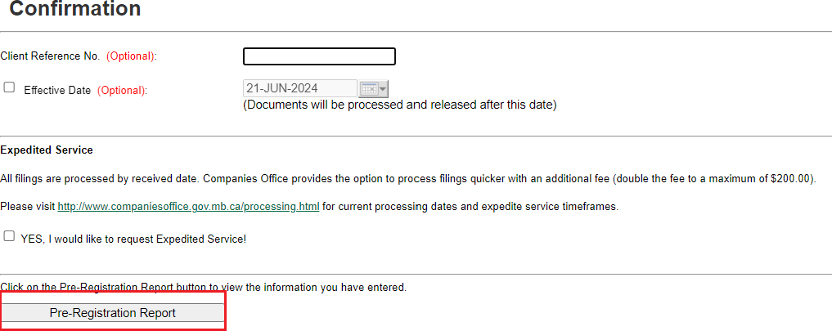

Pre-Registration Report
Review the report.
  - If all information is correct, click on Submit.
  - If any information is incorrect, click on Fix Error. This will take you to the beginning where they can correct the information entered.
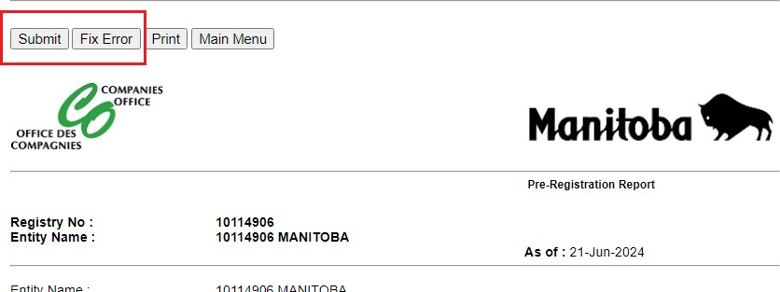

Information Validation
  - Read the statements and click on Yes to each statement.
  - Click on Proceed.
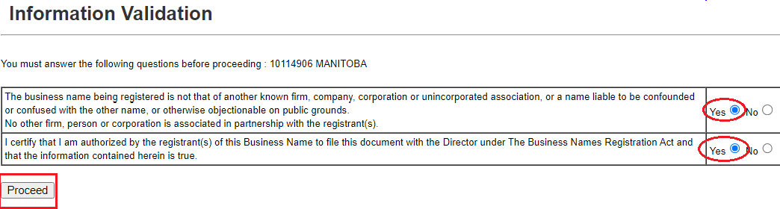

Payment
Enter your Visa or Mastercard information:
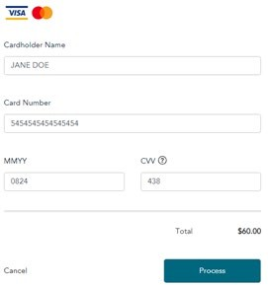

Receipt
Print the receipt, if required. Click on Continue.
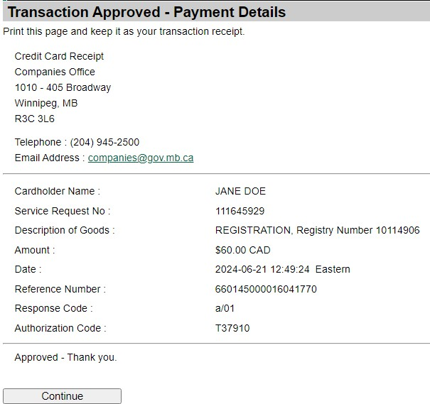

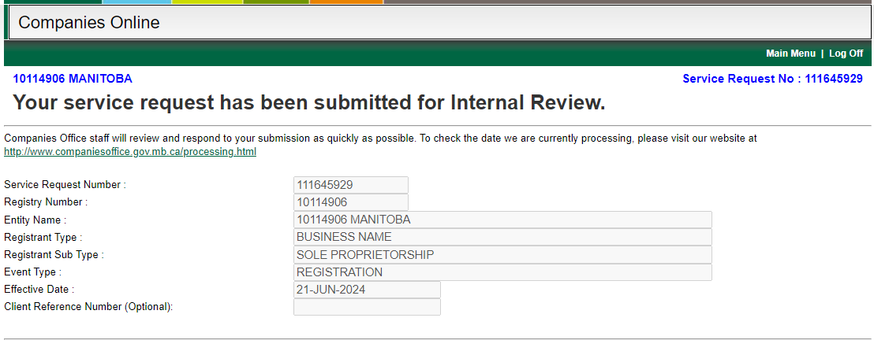

Once the documents have been processed, the following will be emailed:
  - Record of Filing
  - Business Name Registration form
  - Invoice
Note: Information about the Business Number will be sent in a separate email.

Important Information
Remember the username and password used to file this Service Request. You will need it if you:

- Receive an email indicating that the Service Request has been returned to you for corrections. You have 5 days to make the corrections and re-submit the Service Request. Login with this Username and click on the link in the yellow bar to display your returned Service Request:
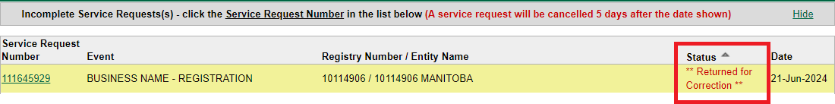
- Need to file documents online to update this registration in the future.

